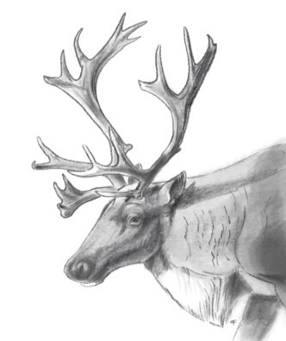

Meeting Minutes April 27, 2022

Actions
Apr. 14-May 12 | BC to respond to IMA, funding work plan, G2G (not being the mechanism BC wants for agreement) and Sec 11 – 7.2 MOU.  Update – on hold | BC
June 23 | BC to draft a MOU (term sheet) ID headers, parameters, roles, and responsibilities – other provisions to be worked on together  - Will be ready for discussion for July 21st meeting – Did not occur. – on hold until Canada can participate  - Oct 27 update: BC and ECCC to draft a term sheet together prior to presenting to MLIB. BC and ECCC to draft prior to Nov 24th meeting. – did not happen | BC
Jan 19 | MOU Agreement  - 3 Governments are looking for an agreement  - Conversations have occurred regarding an IMA, opening the G2G and a Section 11 7.2 MOU  - We believe a section 7.2 MOU is the path to reach agreement and a mechanism to support planning and implementing recovery actions  - An agreement arising from Sect 7.2 requires legal review prior to discussing at this table  - Feb 2 – deferred  - April 27 – Loni to check on status and provide timeline back to group | BC/ECCC
January 19, 2022 | Heather to check in with T8 group to make sure caribou will be a stand-alone piece outside of T8 negotiations  -was asked from C&C at meeting – we will need an answer  -Loni to look into this as Heather has changed positions | Loni
February 2, 2022 | Response to Submission of Technical Report | BC/ECCC
February 2, 2022 | Loni to talk with Ryan on providing a quarterly update to this table regarding decisions in the territory.  - Ryan no longer part of G2G table – Loni to ask Jen Pollard | Loni
March 30, 2022 | Park Expansion  - Brian to send volume info for area (Spectrum) | Brian
April 11, 2022 | Loni to check on funding through the T8 table – is it a form of accommodation? | Loni
April 11, 2022 | Loni to check on MOU – need timeline | Loni
April 11, 2022 | Scott to provide list of papers and who they were sent to | Scott McNay

Overview of Tripartite table from February 2021 – Loni
- Review of PP

- Lisa will provide concise overview of MLIB’s Interests
- Consent-based decision making and co-management framework between MLIB/BC/ECCC

BC funding opportunities – Lisa/Loni
- Review of 2 pager – what we did what we want to do
- 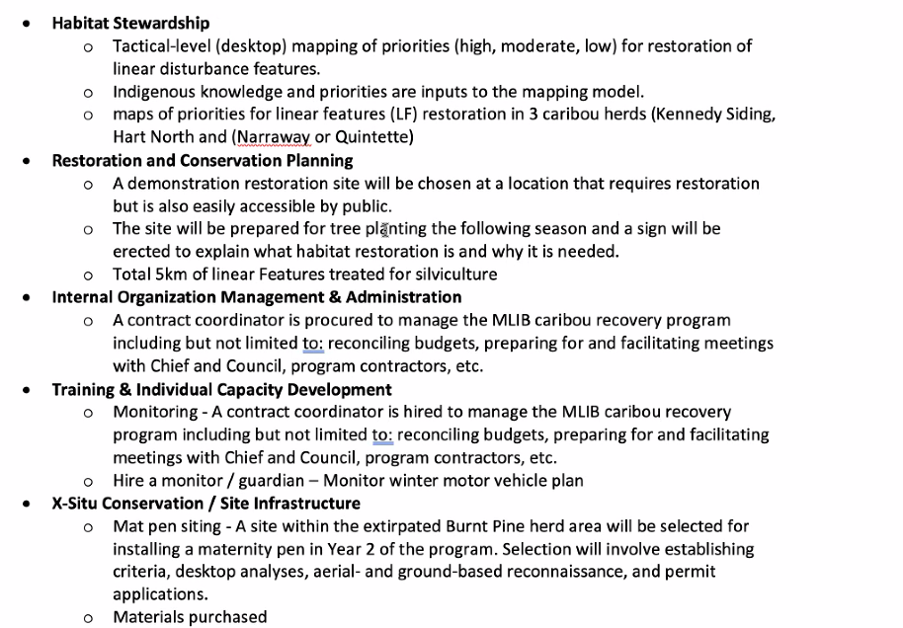
- 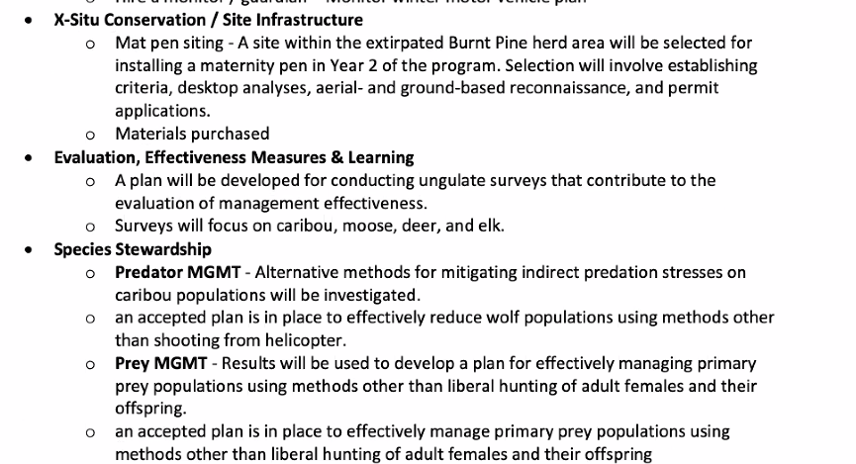
- Field work that has been done – habitat stewardship – developed tactical plan for restoration, building out from Core habitat - completed. Aerial recce of priority areas has been completed. Pass spatial over to Spectrum they are now verifying and developing prescriptions and getting ready to apply for authorizations
- Picked a site for demonstration of habitat restoration techniques close to Mackenzie, road has been ripped, need to plant, and need signage
- Have delivered reports to BC summarizing the demonstration site and tactical plan – Scott to provide to this group
- Have hired consultation to look at other ways for predator reduction, and primary prey (reports are being completed)
- Looked at introducing aerial surveys to monitor winter recreation and have developed a survey technique - has been implemented – final report in the summer.
- Looking at mat pen site to help reintroduction of caribou in Burnt Pine, have done desktop exercise for potential sites, have aerial recce and groundwork to refine boundary have purchased material as well
- Reports have been delivered to BC and pen site report will be soon delivered
- Year 2 – looking for BC to commitment for funding
- Want to hire a coordinator – need multi year funding
- 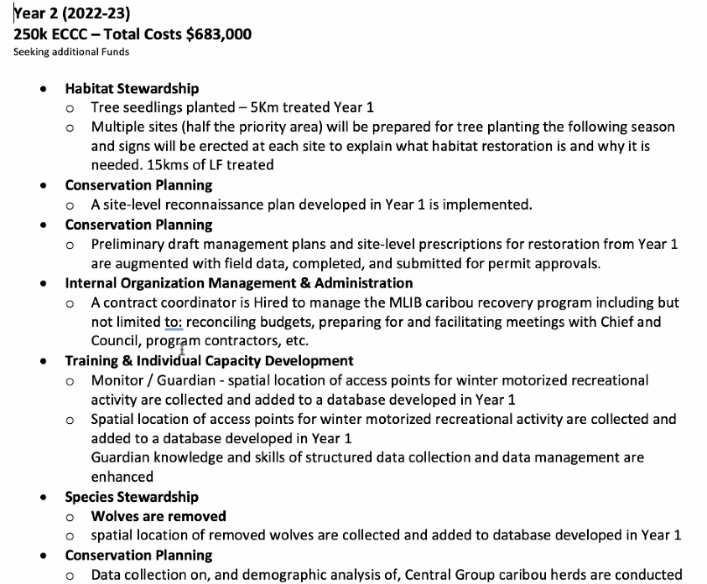
- Year 2 implementing recommendations from reports - primary prey, predator reduction, snow mobile monitoring
- Scott will provide a list of the reports and who they were sent to – Lisa to send to Loni
- BC CRP has submitted approval for funding through IFE for Restoration, Burnt Pine Mat pen and the Ethno study
- Through the Treaty 8 common table BC has requested funding through IFE for the other projects that were identified during the February 2, 2022 tripartite meeting – capacity building - coordinator and guardians, ungulate surveys and through the G2G BC has requested from IFE for CRLUO’s.
  - Loni to check on the funding through the T8 common table – will it be tied to accommodation?

Phase 1 Technical Report review – Robin
- Summary of report
- 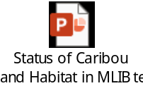
- Overall impressions well written, thanks to MLIB and WI for commissioning it
- MLIB territory is extensive, this report focuses on four of MLIB’s herds of interest Burnt Pine, Kennedy Siding, Scott West, and Hart Ranges (Parsnip)
- From critical habitat perspective all herds exceed thresholds
- Threshold was 35% for Low elevation and matrix
- Most disturbance cut blocks, roads, and spruce beetle
- The disturbance numbers are higher than what BC has identified – may be because they included MPB
- Are very close to ECCC numbers – all show that there is a lot of disturbance
- Take home message is we are above the thresholds that would support caribou recovery
- Robin to summarize questions and provide them to MLIB (Scott) and reconvene as tech folks to discuss
- Near term additional disturbances are largely forestry driven – focus on future cut blocks
- Existing habitat disturbance is significantly higher than recovery strategy
- Herds with most disturbance also contained the least high elevation habitat
- In all cases the low elevation and matrix disturbance is greater than high elevation
- Return in restoration invest will be highest in North Hart
- All populations declining until 2013-2014 that is when recovery actions were put in place; supplemental feeding and wolf control reversed declines in Kennedy Siding
- Caribou movement between ranges – most movement between Kennedy Siding and Burnt Pine, also includes visits by Kennedy Siding after Burnt Pine was considered extirpated
- When is herd declared extirpated in eyes of federal government?
  - Need to be amendment to schedule 1 of SARA, the units of interests are not herds they are entire populations
  - There is a listing process, currently it is listed as Southern Mountain population which includes multiple herds and population units
  - Where recovery strategy shows herds that have been extirpated – not sufficient breeding females left (basically the same as the Province)
- How would translocation be contemplated with amending the recovery strategy? (Kennedy Siding to Burnt Pine)
- Would look at the feasibility of reintroduction because of the disturbance – not a black and white decision
- Caution we are dealing with tactical level imperfect data – field verification needs to be completed to remove areas from what we think is disturbed in Burnt Pine (high density of seismic – some were field checked and now have 4-6 m trees)
- Management actions have occurred in some of the herds – population actions (feeding/wolf control), habitat actions (WHA/UWR)
- Implications for caribou
  - The immediate population management actions have mitigated declines
  - Without the short-term measures, they will not be recovered

Next meeting
- Need timeline for MOU and Parsnip
- Next steps start talking about MOU.
- Loni will look into where the MOU is at and provide timeline to group. May 11th meeting cancelled. Loni to reach out to group the week of May 16th for next meeting (Scheduled May 25th)

